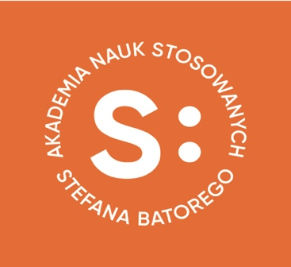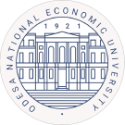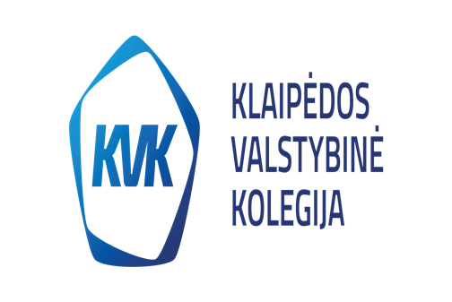

Stefan Batory Academy of Applied Sciences, Skierniewice, Poland
Zhytomyr State University named after Ivan Franko, Ukraine
State University „Zhytomyr Polytechnic”, Ukraine
Odesa National Economic University, Odesa, Ukraine
Academy of Economic Studies of Moldova, Chisinau, Republic of Moldova
Klaipėdos valstybinė kolegija / Higher Education Institution, Klaipeda, Lithuania
“St. Cyril and St. Methodius” University of Veliko Tarnovo, Bulgaria

Are honored to invite to
2nd Student International Scientific and Practical Online Conference
"Administration and management in the functioning of the modern economy and society"
on 27th and 28th of November 2023

Conference format: on-line (MS TEAMS)

Conference language: Polish, Ukrainian, English, Romanian, Russian.

The aim of the conference is to address issues related to the functioning of organizations/companies and the adaptation and effectiveness of activities in response to the changing geopolitical situation of countries and regions.
Conference sections:
- Managing public order (local government system, rights and responsibilities of entities responsible for public order, local security, state security, public administration ethics, judicial administration, the justice system, etc.)
- Economic and political effects of globalization (project management, transfer of modern technologies, cooperation of various enterprises, social policy, political marketing)
- The legal protection system of the European Union (EU administrative bodies, proceedings in the EU institutions, administrative system for the protection of human rights, management in a democratic environment, etc.)
- Financial problems and challenges (public finances, financial law, budgetary policy of state and local structures, structural funds, etc.)
- Management of business structures (enterprise management, innovations, marketing of goods and services, corporate social responsibility, accounting and auditing, international accounting standards, geopolitical problems of modern enterprises, etc.)

General information:
We invite students from the fields of administration and management, as well as students of other faculties interested in management and its role in the functioning of the modern economy and society, to participate in the Conference.

The organizing committee:
Miller Piotr – PhD, prof., Dean of the College of Social and Economics, Stefan Batory Academy of Applied Sciences, Skierniewice, Poland
Burzyńska Dorota – prof, Director of the Institute of Economic and Management Sciences, Stefan Batory Academy of Applied Sciences, Skierniewice, Poland
Botsian Tatjana – doc. nauk ekon., prof. Vice-rector Zhytomyr Univeristy i. Franki, Zhytomyr, Ukraine
Irina Pojta – doc. Department of Economics, Management, Marketing, Hotel ana Catering Business, Zhytomyr Univeristy i. Franki, Zhytomyr, Ukraine

Ostapczuk Tatjana – Doctor of Economics, prof., Head of the Department of Management, Business and Marketing Technologies State University, Zhytomyr Polytechnic University”, Ukraine

Vikarczuk Olga – PhD.in Economics Associate Professor, Department of Management, Business and Marketing Technologies State University, Zhytomyr Polytechnic University”, Ukraine

Łokhanowa Natalia – Doctor of Economics, prof., Head of the Department of Accounting, Analysis and Audit, Odesa National Economic University, Odesa, Ukraine

Robertus Kavolius – Lecturer, Head of the Student’s Scientific Society, Klaipėdos valstybinė kolegija / Higher Education Institution, Klaipeda, Lithuania
Lilia GRIGOROI, PhD, Dean of Accounting Faculty, Academy of Economic Studies of Moldova
Liliana LAZARI, PhD, Head of Department of Accounting, Audit and Economic Analysis, Academy of Economic Studies of Moldova
Maia BAJAN, PhD, Vice Dean of Accounting Faculty, Academy of Economic Studies of Moldova
Slavi Dimitrov – professor, “St. Cyril and St. Methodius” University of Veliko Tarnovo, Bulgaria

Conference secretaries:

Ewelina Kiełek – Więcławska – PhD, Institute of Economic and Management Sciences, Stefan Batory Academy of Applied Sciences, Skierniewice, Poland; ewieclawska@ansb.pl

Wiśniewski Konrad – master, Institute of legal and Security Sciences, Stefan Batory Academy of Applied Sciences, Skierniewice, Poland

Yatsunska Olesia –PhD, Department of Accounting, Analysis and Audit, Odesa National Economic University, Odesa, Ukraine

Lewandowska Hanna – PhD., prof. Coordinator for academic cooperation with Reasmus+ partner countries, Stefan Batory Academy of Applied Sciences, Skierniewice, Poland

Terms and conditions of partcipation in the conference:

- On 17th to 20th of November 2023, an electronic application for participation and a presentation should be sent to the following address: ewieclawska@ansb.pl together with the attached publication, a review of the supervisor's consent to the publication.

- On 27th and 28th of November 2023 PowerPoint presentation of articles prepared by students (Microsoft Teams) - max speaking time 15 minutes.

- On 2nd and 3rd of December 2023 all publications will be published on
on the following websites: Stefan Batory Academy of Applied Sciences, https://www.ansb.pl; Zhytomyr State University: http://spf.zu.edu.ua/konferens_ekonom.html; Zhytomyr Polytechnic State University (https://conf.ztu.edu.ua/); Odessa National University of Economics: http://dspace.oneu.edu.ua/jspui/handle/123456789/163.

- At the end of the conference, the best articles will be published
in the electronic scientific publication of the Stefan Batory Academy of Applied Sciences, ISBN .....

5. Participation in the conference is free of charge for all participants.

Editorial standards:

- Text size 6–10 pages
- 5–6 keywords
- Introduction in English no more than 150–200 words
- Summary in English 100–150 words
- A4 format
- Line spacing 1.5
- 2 cm fields on each side of the page
- Font: Times New Roman
- Font size: 12, justified. Chapter and subsection headings: 12 pts, in bold
- Information about the authors (no more than 3) should include: the name and surname of the student(s), the name and first name of the supervisor(s), the name of the university, the city, the country, and the e-mail address for correspondence
- Text, photos, and charts with source indication: according to the attached template
- No page numbering
- Without moving words to a new line

Правила цитирования:
APA формат структуры:
Author, A. A., Author, B. B., Author, C. C. (Year). Title of book. Place of publication (city, country): Publisher.
APA пример формата:
Frank, R. H. , & Bernanke, B. (2007). Principles of macro-economics (3rd ed.). Boston, MA: McGraw-Hill/Irwin.

Publication template

Student :
…………………….
Name and surname
Speciality: ……………….
Supervisor:
……………………………
Surname, academic title, University name
e- mail adress: ……………………

Title ………………………………………..
Key words: ……………………………………………………………………………………..
Abstract………………………………………………………………………………………….
Tekst…………………………………………………………………………………………….…………………………………………………………………………………………………..
Table 1.
Title:

Source(s):

Picture. 1.
Title

Source(s):

In the case of our own study, we write:

Source: In-house analysis based on .....

BIBLIOGRAPHY
- Bakirov, V., & Oharkov, M. (2021). Pandemiia mozhe nazavzhdy zminyty vyschu osvitu [A pandemic can change higher education forever]. Dzerkalo tyzhnia – Mirror of the week. Retrieved from https://zn.ua/ukr/EDUCATION/pandemija-mozhenazavzhdi-zminiti-vishchu-osvitu.html [in Ukrainian].
- Brammer, S., & Clark, Т. (2020). COVID-19 and Management Education: Reflections on Challenges, Opportunities, and Potential Futures. British Journal of Management, vol. 31, 453-456. [in English].
- Jensen, T. (2019). Higher Education in the Digital Era. The Current State of Transformation Around the World. International Association of Universities. P. 28-42. Retrieved from https://www.iau-aiu.net/IMG/pdf/technology_report_2019.pdf [in English].

Application form:

Name, Surname/ year of study
………………………………………………………………………
Student’s email address
………………………………………………………………………………………………………
Supervisor’s name and surname
…………………………………………………………………………
Function:
…………………………………………………………………………
Academic degree, position
…………………………………………………………………………………………………
Name od the Univeristy (Institute, department))
…………………………………………………………………………
Telephone (Viber, WhatsApp) +380 ………………………………

E-mail address of the scientific supervisor
…………………………………………………………………………

Title of the paper:
…………………………………………………………………………

……………………………………………………..
Name and Surname

……………………………………………………..
Mailing address

………………………………………………………
telephone

………………………………………………………
e-mail

COPYRIGHT TRANSFER STATEMENT

I, the undersigned, declare that I am the author of the article titled

…………………………………………………………………………………………………

and I have copyrights in accordance with the Act of 4 February 1994 (Journal of Laws of 1994 No. 24 item 83 as amended) on copyright and related rights, both to the text, tables and illustrative material (photographs, drawings, charts) included in this article.
I transfer free of charge to the Stefan Batory Academy of Applied Sciences in Skierniewice, Poland the economic copyrights in the scope of publication of this article (in printed and electronic form), published by the Publishing House of the Stefan Batory Academy of Applied Sciences in Skierniewice, Poland.
I declare that:
the article is wholly original and does not contain any borrowings from another work that could give rise to the publisher's liability;
− the article has never been published before;
− the submitted paper has not yet been published in print and has not been submitted to another editorial office;
− the copyright in this article is not limited to the extent covered by this statement;
− The Publisher has the right to make the necessary changes to the article, resulting from the
from the editorial study.

……………………………………… ………………………………………..
place and date signature of the author - student

……………………………………….
Supervisor’s signature

